|  |  |
| --- | --- |
| Date | **10 November 2022** |
| TeamID | PNT2022TMID50435 |
| ProjectName | SmartFashionRecommenderApplication |
| Teammembers | Tamil Selvan  Arun Vignesh  Mathesh  Mosai |

SendgridOpenPage:



SendgridloginPage:

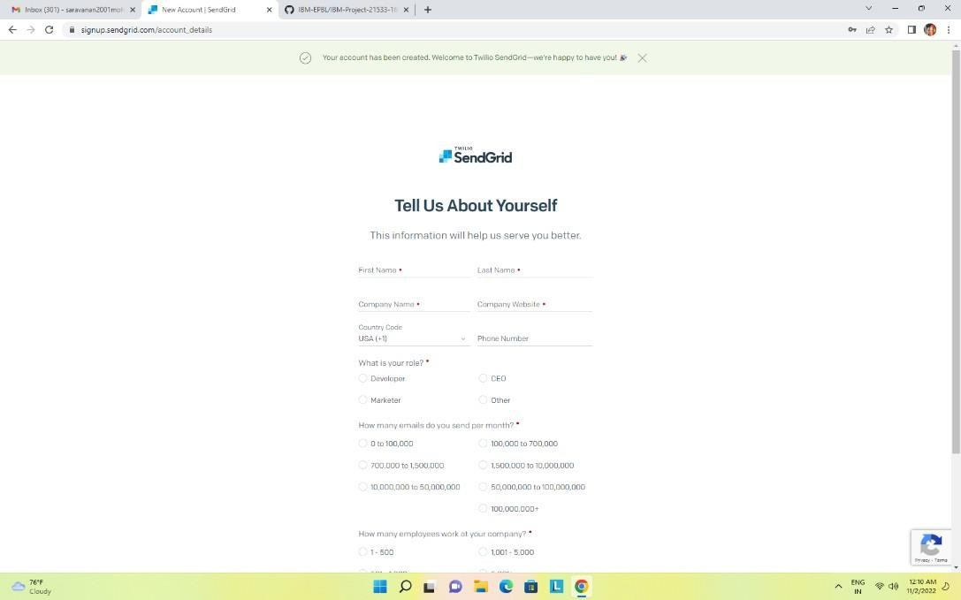

Sendgridsuccessfullycreated:

